Jeff Sherard
CSC160C11
7/2/2013

Documentation for Ch05_Ex09 Program

Problem Analysis

A program using while loops to perform the following steps:

- Prompt the user to input two integers: firstNum and secondNum (firstNum must be less than secondNum).
- Output all odd numbers between firstNum and secondNum.
- Output the sum of all even numbers between firstNum and secondNum.
- Output the numbers and their squares between firstNum and secondNum.
- Output the sum of the square of the odd numbers between firstNum and secondNum.
- Output all uppercase letters.

Algorithm

- Define variables:
  - int firstNum
  - int secondNum
  - int sumEven

- Get input:
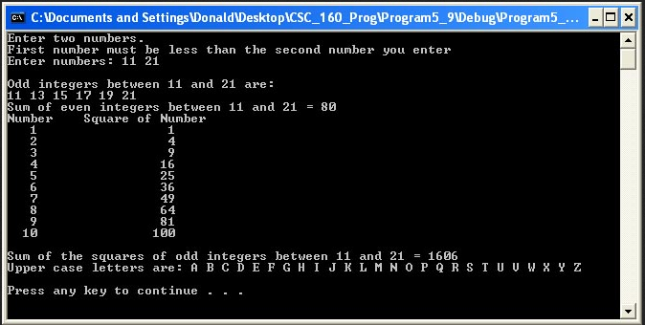

- Calculate:
Number % 2 = 0 is an even number
Number % 2 != 0 is an odd number
setw formatting required
all using counter controlled while loops

- Output:

User Documentation

To run the program the user will double click Ch4_Ex14.exe located on the C drive. After the program has loaded and the design is displayed, the user will be prompted to, “Press any key to continue…” which will terminate the program. Output will be displayed on the screen.

